##### Questions:

1. Populateallthefivetableswithyourowndata.
2. Updatethevalueofstudentnamewhoseregisternumber is ‘191711342’
3. Delete therecordinthe tableFACULTY,whoresignedherjob.
4. Modifythedateof birth forthefaculty whosenameis 'RAM'with avalue‘1983-05-01’.
5. Removeallfacultywhoarehavingover65years
6. Viewalltherecordsfromthefivetables.

1)

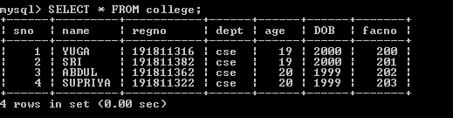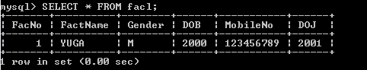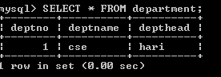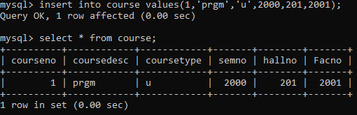

2)



3)



4)

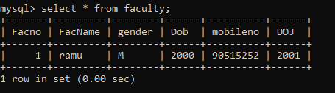

5) 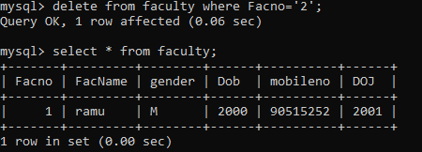

6)

